**A Training Report**

**On**

# “Talking Dictionary”

Submitted to the Sri Balaji PG Mahavidyalaya, Jaipur in

Partial fulfillment of the requirement for the degree of

**BACHELOR OF COMPUTER APPICATIONS**



**University of Rajasthan**

**BCA-(2022-24)**

April 2025)

**Under the Supervision of**

**Dr. Divya Sain**

**Submitted by**

Animesh Mathur

# Table of Content

|  |  |  |  |
| --- | --- | --- | --- |
| S.No |  | Content | Page no. |
| 1. | Certificate |  |  |
| 2. | Acknowledgement |  |  |
| 3. | Introduction |  |  |
| 4. | System Study |  |  |
| 5. | System Analysis |  |  |
| 6. | System Design |  |  |
| 7. | Development |  |  |
| 8. | Testing |  |  |
| 9. | System Security |  |  |
| 10 | Conclusion |  |  |

# Certificate

This is to certify that the Project (BCA-310) work entitled “Talking Dictionary” submitted by Animesh Mathur (RU Roll No. 466546 ) to the Department of Bachelor of Computer Application of Sri Balaji PG Mahavidyalaya has been examined and evaluated.

The Project work has been prepared as per the regulations of Sri Balaji PG Mahavidyalaya, Jaipur and qualifies to be accepted in partial fulfilment of the requirement for the degree of BCA (Bachelor of Computer Applications)

Internal Examiner External Examiner

Head of Department

## ACKNOWLEDGEMENT

I would like to express my sincere gratitude to all those who supported me throughout the completion of this project titled: **“Talking Dictionary”**

I express our heart full and owe a deep sense of gratitude to my teacher and my faculty guide Dr Divya Sain, SBPGM, for their sincere guidance, encouragement, and suggestion, inspired and have contributed immensely to the evolution of our ideas on the project.

I am extremely thankful to all faculty member of BCA dept. of Sri Balaji PG Mahavidyalaya for their coordination and cooperation and for their kind guidance and encouragement.

I also thank our friends who have more or less contribution to the preparation of this project report. I will be always indebted to them.

The study has indeed helped is to explore more knowledge avenues related to my topic and I am sure it will help us in our future.

A heartfelt thanks to my **parents and family members** for their constant motivation and moral support. I also extend my thanks to my **friends and classmates** who directly or indirectly helped me in completing this project.

Thank You

## Introduction

### Project Overview

The **Talking Dictionary** is a Python-based desktop application that provides users with word definitions through a user-friendly graphical interface. It not only displays the meaning of the words but also pronounces them aloud using text-to-speech functionality, making it especially helpful for learners aiming to improve their vocabulary and pronunciation skills.

The application serves as an interactive tool where users can enter a word and instantly get its meaning sourced from a structured **JSON dictionary file**. If the word is found, its meaning is displayed and spoken aloud; if not, an appropriate message is shown. This simple yet powerful educational utility can be used by students, language learners, and anyone needing quick access to word meanings and pronunciations.

**The website features:**

1. **Graphical User Interface (GUI):** Built using the Tkinter library, offering an intuitive and responsive layout.
2. **Word Search Functionality:** Users can enter words and retrieve their definitions from a JSON-based dictionary.
3. **Text-to-Speech (TTS):** Implements the pyttsx3 library to read out the word and its meaning aloud.
4. **JSON Dictionary File:** The application uses a pre-defined JSON file as the back-end data source for word-meaning pairs.
5. **Error Handling:** Displays user-friendly messages for misspelled or unfound words.
6. **Responsive Layout and Styling**: Includes hover effects, scrollbars, custom icons, and enhanced visuals for improved user experience.

### Problem Description

In the digital age, while learning resources are widely available, many users still struggle with accessing a simple, fast, and pronunciation-friendly dictionary tool. Most available solutions are either online, complex to use, or lack audio support for pronunciation. This creates a gap for learners who need an offline, easy-to-use dictionary with voice functionality.

* **Dependence on Internet** – Most dictionaries require an active internet connection to function.
* **No Pronunciation Support** – Users cannot hear correct pronunciation, affecting spoken vocabulary.
* **Complex or Cluttered Interfaces** – Many dictionary tools are bloated with ads or unnecessary features.
* **Lack of Offline & Lightweight Tools** – Limited availability of simple, educational, desktop-based dictionaries.

To solve these issues, the **Talking Dictionary** was developed as a desktop GUI application that is fast, user-friendly, works offline, and includes text-to-speech pronunciation support.

**Need for the Project**

With the growing importance of digital learning, there is a clear need for a tool that helps users—especially students and language learners—enhance their vocabulary and pronunciation without relying on internet-based solutions. Most existing dictionary platforms are either web-based or lack pronunciation support, making them less suitable for all learning environments.

Major Reasons for the Need:

* **Offline Accessibility** – Many users don’t have consistent internet access; an offline tool ensures uninterrupted learning.
* **Support for Pronunciation** – Listening to word pronunciation improves spoken English and reduces miscommunication.
* **Simple and Intuitive Interface** – Learners, especially beginners, need an easy-to-use interface without distractions.
* **Educational Utility** – A tool that enhances both reading and listening skills can be widely used in schools and learning centers.

The *Talking Dictionary* meets these needs by providing a lightweight, offline, and voice-enabled dictionary experience through a user-friendly desktop application.

### About Organization

The project *Talking Dictionary* has been developed under the academic guidance of [Your University/College Name], which offers a variety of undergraduate and postgraduate programs in computer science and related fields. The institution emphasizes practical learning through real-world projects, helping students apply theoretical knowledge to real-time applications.

As part of this hands-on learning approach, the *Talking Dictionary* project was conceptualized and implemented to address common language-learning challenges. It reflects the university's commitment to fostering innovation and problem-solving through software development, encouraging students to build solutions that are useful in educational and self-learning environments.

## SystemStudy

### Existing System with Limitations

In the current scenario, most users rely on printed dictionaries or online dictionary websites to look up word meanings. Printed dictionaries are bulky, time-consuming to search through, and lack pronunciation support. Online dictionaries, while faster, require constant internet connectivity and often come with distracting ads or subscription barriers. Moreover, many of these platforms do not cater to users who prefer a simple, ad-free, offline solution with both text and speech support.

**Limitations of Existing System:**

* Requires constant internet access
* Lacks offline pronunciation features
* Complex or ad-heavy user interfaces
* Not suitable for quick access during offline learning
* Limited customization or educational focus

### Proposed System with Objectives

The proposed system, Talking Dictionary, is a desktop-based graphical dictionary application that overcomes the limitations of traditional and online dictionaries. It enables users to search for word meanings and hear their pronunciation using offline text-to-speech functionality.

**Objectives of the Proposed System:**

* To develop an offline, user-friendly desktop application for word search and pronunciation.
* To integrate text-to-speech features for better learning and pronunciation support.
* To eliminate the need for internet dependency during vocabulary learning.
* To offer a clean, ad-free, and distraction-free learning environment.
* To assist students, learners, and users in quickly finding meanings and listening to pronunciations.

### Significance of the Project

This project holds significant value for students, language learners, and educators. It provides a simple yet effective platform for improving vocabulary and pronunciation without relying on internet access. By offering offline accessibility, it supports inclusive and continuous learning, especially in areas with limited connectivity.

**Key Significances:**

* Enhances vocabulary and pronunciation skills through an interactive interface.
* Supports digital and self-paced learning without internet dependency.
* Saves time by offering instant word meaning and voice output.
* Encourages the development of educational software tools using Python.

### Beneficiaries of the System

The primary users and beneficiaries of the Talking Dictionary system include:

* **Students and Language Learners** – who can easily find meanings and hear correct pronunciation for better learning.
* **Teachers and Educators** – who can use the tool to assist in classroom vocabulary activities.
* **Self-learners** – who benefit from a distraction-free, offline learning environment.
* **Developers and Technical Teams** – who can enhance or scale the project by adding features like word history, quizzes, or multi-language support.

### Feasibility Study

1. **Economic Feasibility**: The Talking Dictionary is economically feasible as it is developed using free and open-source technologies such as **Python**, **Tkinter**, **pyttsx3**, and **JSON**. No paid tools or licenses are required. As it is a desktop application, there are no hosting or server infrastructure costs. It also eliminates the need for printed dictionaries and reduces dependency on paid online services.
2. **Technical Feasibility:** The system is technically feasible and easy to implement. It uses well-supported Python libraries like Tkinter for GUI and pyttsx3 for text-to-speech functionality. The dictionary data is stored in a lightweight JSON file, ensuring fast and efficient access. The system is compatible with most desktop operating systems and requires minimal system resources.
3. **Duration Feasibility:** The project was completed within an estimated duration of **8 days**, distributed as follows:
   * Planning and designing: 2 days
   * Development and testing: 3 days
   * Debugging, documentation & deployment: 3 days

## System Analysis

**System Flow Chart**

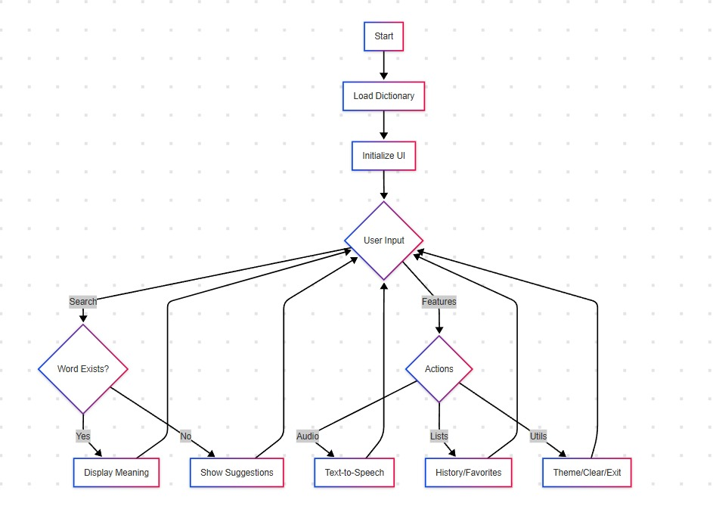

**E-R Diagram**

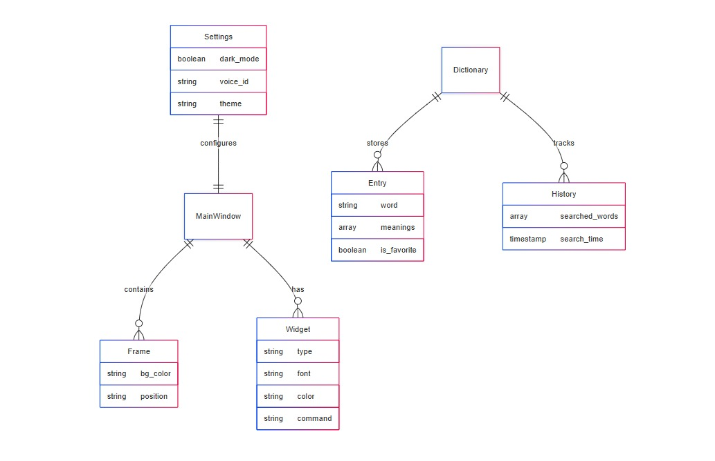

**Data Flow Diagram**

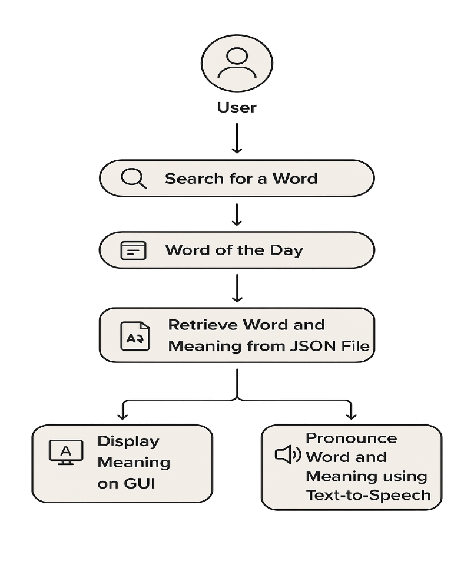

### Data Flow Diagram Required Specification

1. **Functional Requirements:** These are the core features that the system must perform:

* User must be able to open the desktop application.
* User should be able to **search for any word** using the input field.
* User can also **view the “Word of the Day”** recommended by the system.
* On clicking "Search" or "Word of the Day", the system should **retrieve the word's meaning and pronunciation** from the JSON file.
* The **text meaning** should be displayed, and the **word and meaning should be spoken aloud** using text-to-speech.

1. **Non-Functional Requirements:** These define the quality and performance of the system:
   * The application should work **smoothly on Windows/Linux desktops**.
   * The interface should be **responsive and simple to navigate**.
   * The application should **start quickly and load results in real-time**.
   * No internet is required, ensuring **100% offline accessibility**.
   * The design should follow a **clean, clutter-free layout with focus on usability**.
2. **User Requirements :** These are requirements from the user’s perspective:
   * User should be able to **run the app without installation of heavy dependencies**.
   * App interface must be **easy to understand and operate for all age groups**.
   * **Audio feedback** should be clear and useful for pronunciation learning.
   * User should receive a **message when a word is not found** in the dictionary.
3. **System Requirements :** These are the hardware and software needs to run or develop the project:

**Software Requirements:**

* + Code Editor: VS Code / PyCharm
  + Programming Language: Python
  + Libraries: Tkinter (GUI), pyttsx3 (TTS), json (data handling)

**Hardware Requirements:**

* + Minimum 4GB RAM
  + Internet Connection
  + Windows/Linux OS

### SRS (Software Requirement Specification)

The **Software Requirements Specification (SRS)** is a detailed document that defines the purpose, functionality, and behavior of the **Talking Dictionary** desktop application.

**Purpose of the Project:** To develop an **offline desktop-based dictionary** that allows users to search for word meanings and hear their pronunciations using a GUI application

**Scope:**

* Build a **lightweight desktop application** with a user-friendly interface.
* Retrieve word meanings and pronunciations from a **local JSON dictionary file**.

**Modules:**

1. Word Search Module
2. Word of the Day Module
3. Text-to-Speech
4. JSON Data Handler

**Technology Stack:**

* Frontend: Python Tkinter
* Backend: Python (Core functionality, pyttsx3, JSON)
* Database: JSON file (used as a local dictionary database)
* Deployment: Packaged as a standalone desktop executable (via PyInstaller or similar)

### Risk, Assumption and Constraints

**Risks:**

* Library Compatibility Issues: Some Python libraries (e.g., pyttsx3) may behave differently across platforms.
* Audio Output Dependency: The system depends on the presence of working speakers or audio drivers.
* Data Integrity: If the JSON file is accidentally modified or deleted, the dictionary functionality may fail.

**Assumptions:**

* Users will have **basic knowledge of using desktop applications**.
* The system will function **offline**, and users are **not expected to have an internet connection**.

**Constraints:**

* The system does **not include word addition or editing features** in the current version (future scope).
* The dictionary is **limited to the words available** in the existing JSON file.

## System Design

### Software Development Life Cycle (SDLC)

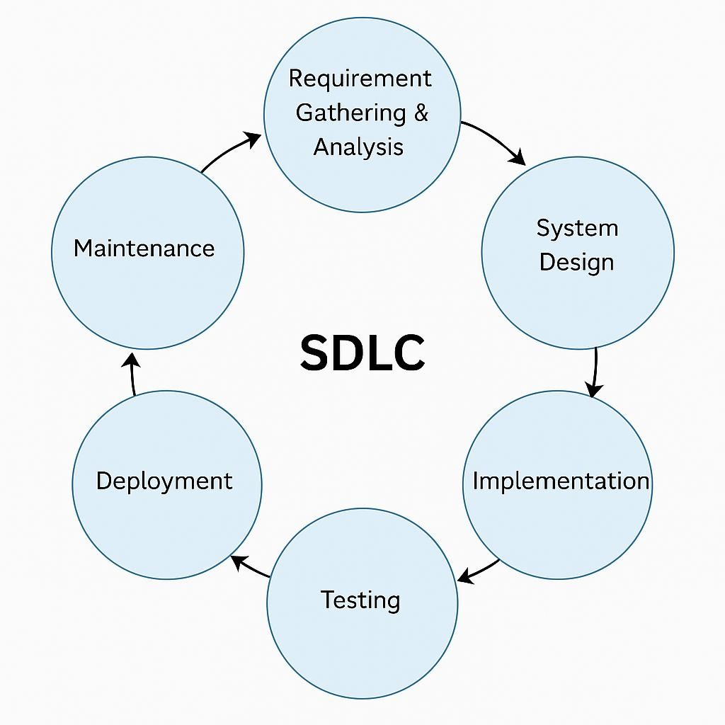

**SDLC Model Used: Waterfall Model**

For the **Talking Dictionary** desktop application, the **Waterfall Model** was followed as the Software Development Life Cycle (SDLC) methodology. This model is ideal for academic and small-scale projects where requirements are clearly defined from the beginning.

### Screen Shot of Main Graphical User Interface

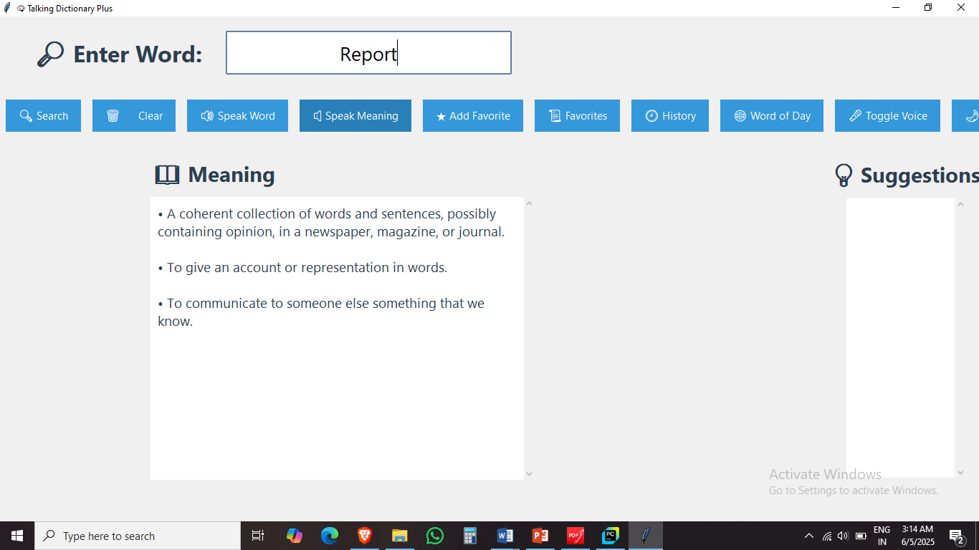

## Development

### Environment

The **Talking Dictionary** application was developed in a simple yet effective development environment using Python and open-source tools. The setup supports quick prototyping and smooth GUI-based application development.

* **Programming Language:** Python
* **Frontend (GUI):** Tkinter (Python’s standard GUI library)
* **Text-to-Speech Engine:** pyttsx3 (offline TTS library)
* **Data Source:** JSON file (used as a local dictionary database)
* **Packaging Tool:** PyInstaller (for creating standalone executable)
* **Version Control:** Git & GitHub

### Coding Style

A clean, modular, and readable coding style was followed to ensure **ease of understanding, scalability**, and **future maintenance** of the Talking Dictionary desktop application.

* **Modular Code Structure:** Each functional part like GUI, TTS engine, word retrieval, and error handling was organized into separate functions.
* **Consistent Indentation:** 4-space indentation used throughout.
* **Naming Conventions:**

o snake_case for variable and function names (e.g., get_meaning(), play_pronunciation())

### Coding Techniques

The project followed standard modern GUI coding techniques:

* **Event Handling:**
  + Used Tkinter's command callbacks to trigger events like search and play actions.
  + Entry widgets captured user input, and Button widgets triggered retrieval and playback.
* **Data Handling:**
  + A JSON file acted as a backend dictionary, loaded at runtime using the json module.
* **Text-to-Speech Integration:**
  + pyttsx3 was used for offline pronunciation, with customized rate and voice configuration.
* **Error Handling:**
  + Message boxes (tkinter.messagebox) provided user-friendly error or info notifications.

## Testing

The **Talking Dictionary** desktop application underwent multiple stages of manual testing to ensure functionality, pronunciation accuracy, and error handling. Due to the academic and small-scale nature of the project, manual testing was performed, adhering to the core principles of standard software testing.

### Unit Testing

**Objective:** To test individual components of the application in isolation.

* Core functions like get_meaning(), speak_word(), and play_meaning() were tested in isolation.
* The TTS (Text-to-Speech) module was checked with different words and phrases to verify clear pronunciation.
* JSON data parsing was validated by modifying test entries and ensuring accurate output.

### System Testing

**Goal:** To test the system as a whole, ensuring components work together properly.

* GUI responsiveness was tested across different screen resolutions and operating systems (Windows/Linux).
* The flow from user input → meaning retrieval → audio playback was tested end-to-end.
* Error messages and fallback behavior were tested for missing or undefined words.

### Alpha and Beta Testing

* **Alpha Testing** was performed by the developer in a controlled environment to catch bugs.
* **Beta Testing** involved peers and students using the application to gather feedback on usability, interface clarity, and pronunciation accuracy.

## System Security

• Although the **Talking Dictionary** is an offline desktop application, several precautions were implemented to ensure data integrity, safe user interaction, and secure coding practices

### Checks and Controls

**1. Input Validation Controls:**

* User input (searched word) is validated to prevent crashes or unexpected behavior.
* Empty input triggers an informative error message using tkinter.messagebox.
* Invalid or unrecognized words are handled gracefully with fallback responses.

**2. JSON Data Access Validation:**

* The system checks for the existence of the word in the JSON file before attempting access.
* Try-except blocks ensure the program doesn't crash on missing or malformed entries.

### Secure Practices

**1. Local File Access Only:**

• The application reads data from a **local JSON file**, eliminating risks of data interception during transmission.

**2. TTS Safety:**The pyttsx3 library is used locally for text-to-speech, avoiding any external API calls or exposure to third-party services.

1. **No Sensitive Data:** The application does not request, store, or transmit any personal or sensitive information, significantly reducing privacy risks.

Conclusion

### Findings

The **Talking Dictionary** desktop application was successfully developed to provide a fast, interactive, and user-friendly platform for users to search the meaning and pronunciation of English words.

* The system replaces the need to manually search in physical dictionaries or browse the internet.
* Meanings are retrieved in real-time from a local JSON file, ensuring quick access even offline.
* Pronunciation of the word and its meaning is provided using text-to-speech functionality.
* The “Word of the Day” feature helps users learn new vocabulary daily, making it educational and engaging.

Overall, the project meets its primary objective of offering a simple, offline dictionary tool with pronunciation support, enhancing vocabulary building in an accessible way.

### Limitations

While the application works well, it has a few limitations:

* **Limited word database**: Meanings are only available for words present in the JSON file.
* **No option to add new words**: Can not add new words via the GUI.
* **Basic GUI**: A Basic GUI without advanced animations

### Future Enhancements

The following features can be added in the future to improve the system:

* **Add Word Entry via GUI**: Allow users or admins to add new words directly from the app.
* **Multilingual Support**: Extend the dictionary to support multiple languages.
* **Database Migration**: Optionally switch to a small embedded database (e.g., SQLite) for scalability.